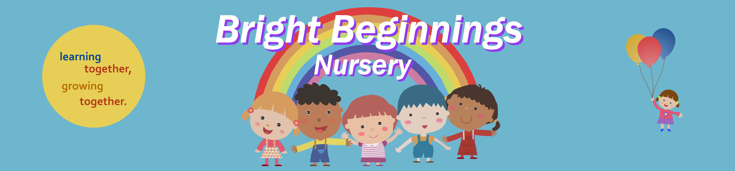
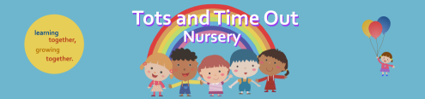
34 Eshton Road, Eastbourne BN22 7ES 93 Enys Road, Eastbourne BN21 2DX
01323 726132 01323 648484

Staying Healthy
&
Keeping Fit



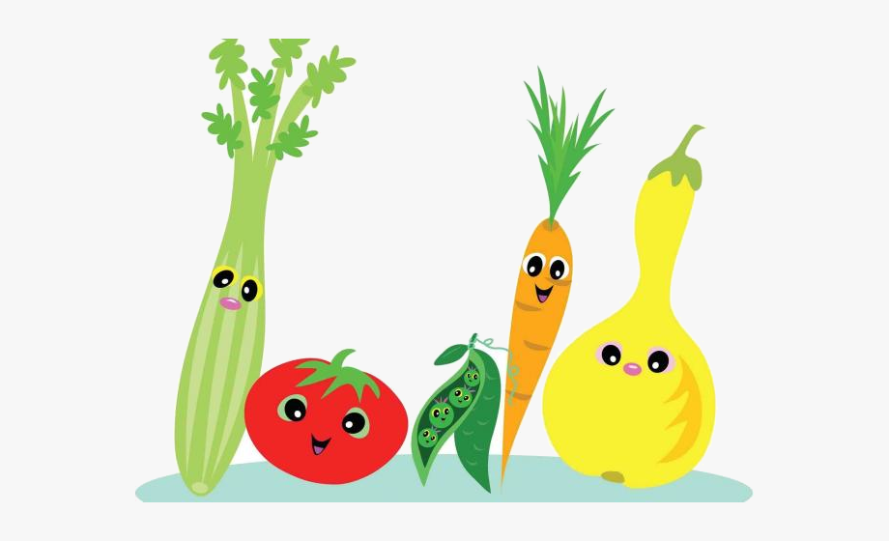

Why is healthy eating important in early years?

Good nutrition is essential during childhood, as it is a time of rapid growth, development and activity. This is also a vital time for healthy tooth development and prevention of decay. General eating habits and patterns are formed in the first few years of life.
The Eatwell Guide shows how much of what we eat overall should come from each food group to achieve a healthy, balanced diet.
You do not need to achieve this balance with every meal, but try to get the balance right over a day or even a week.

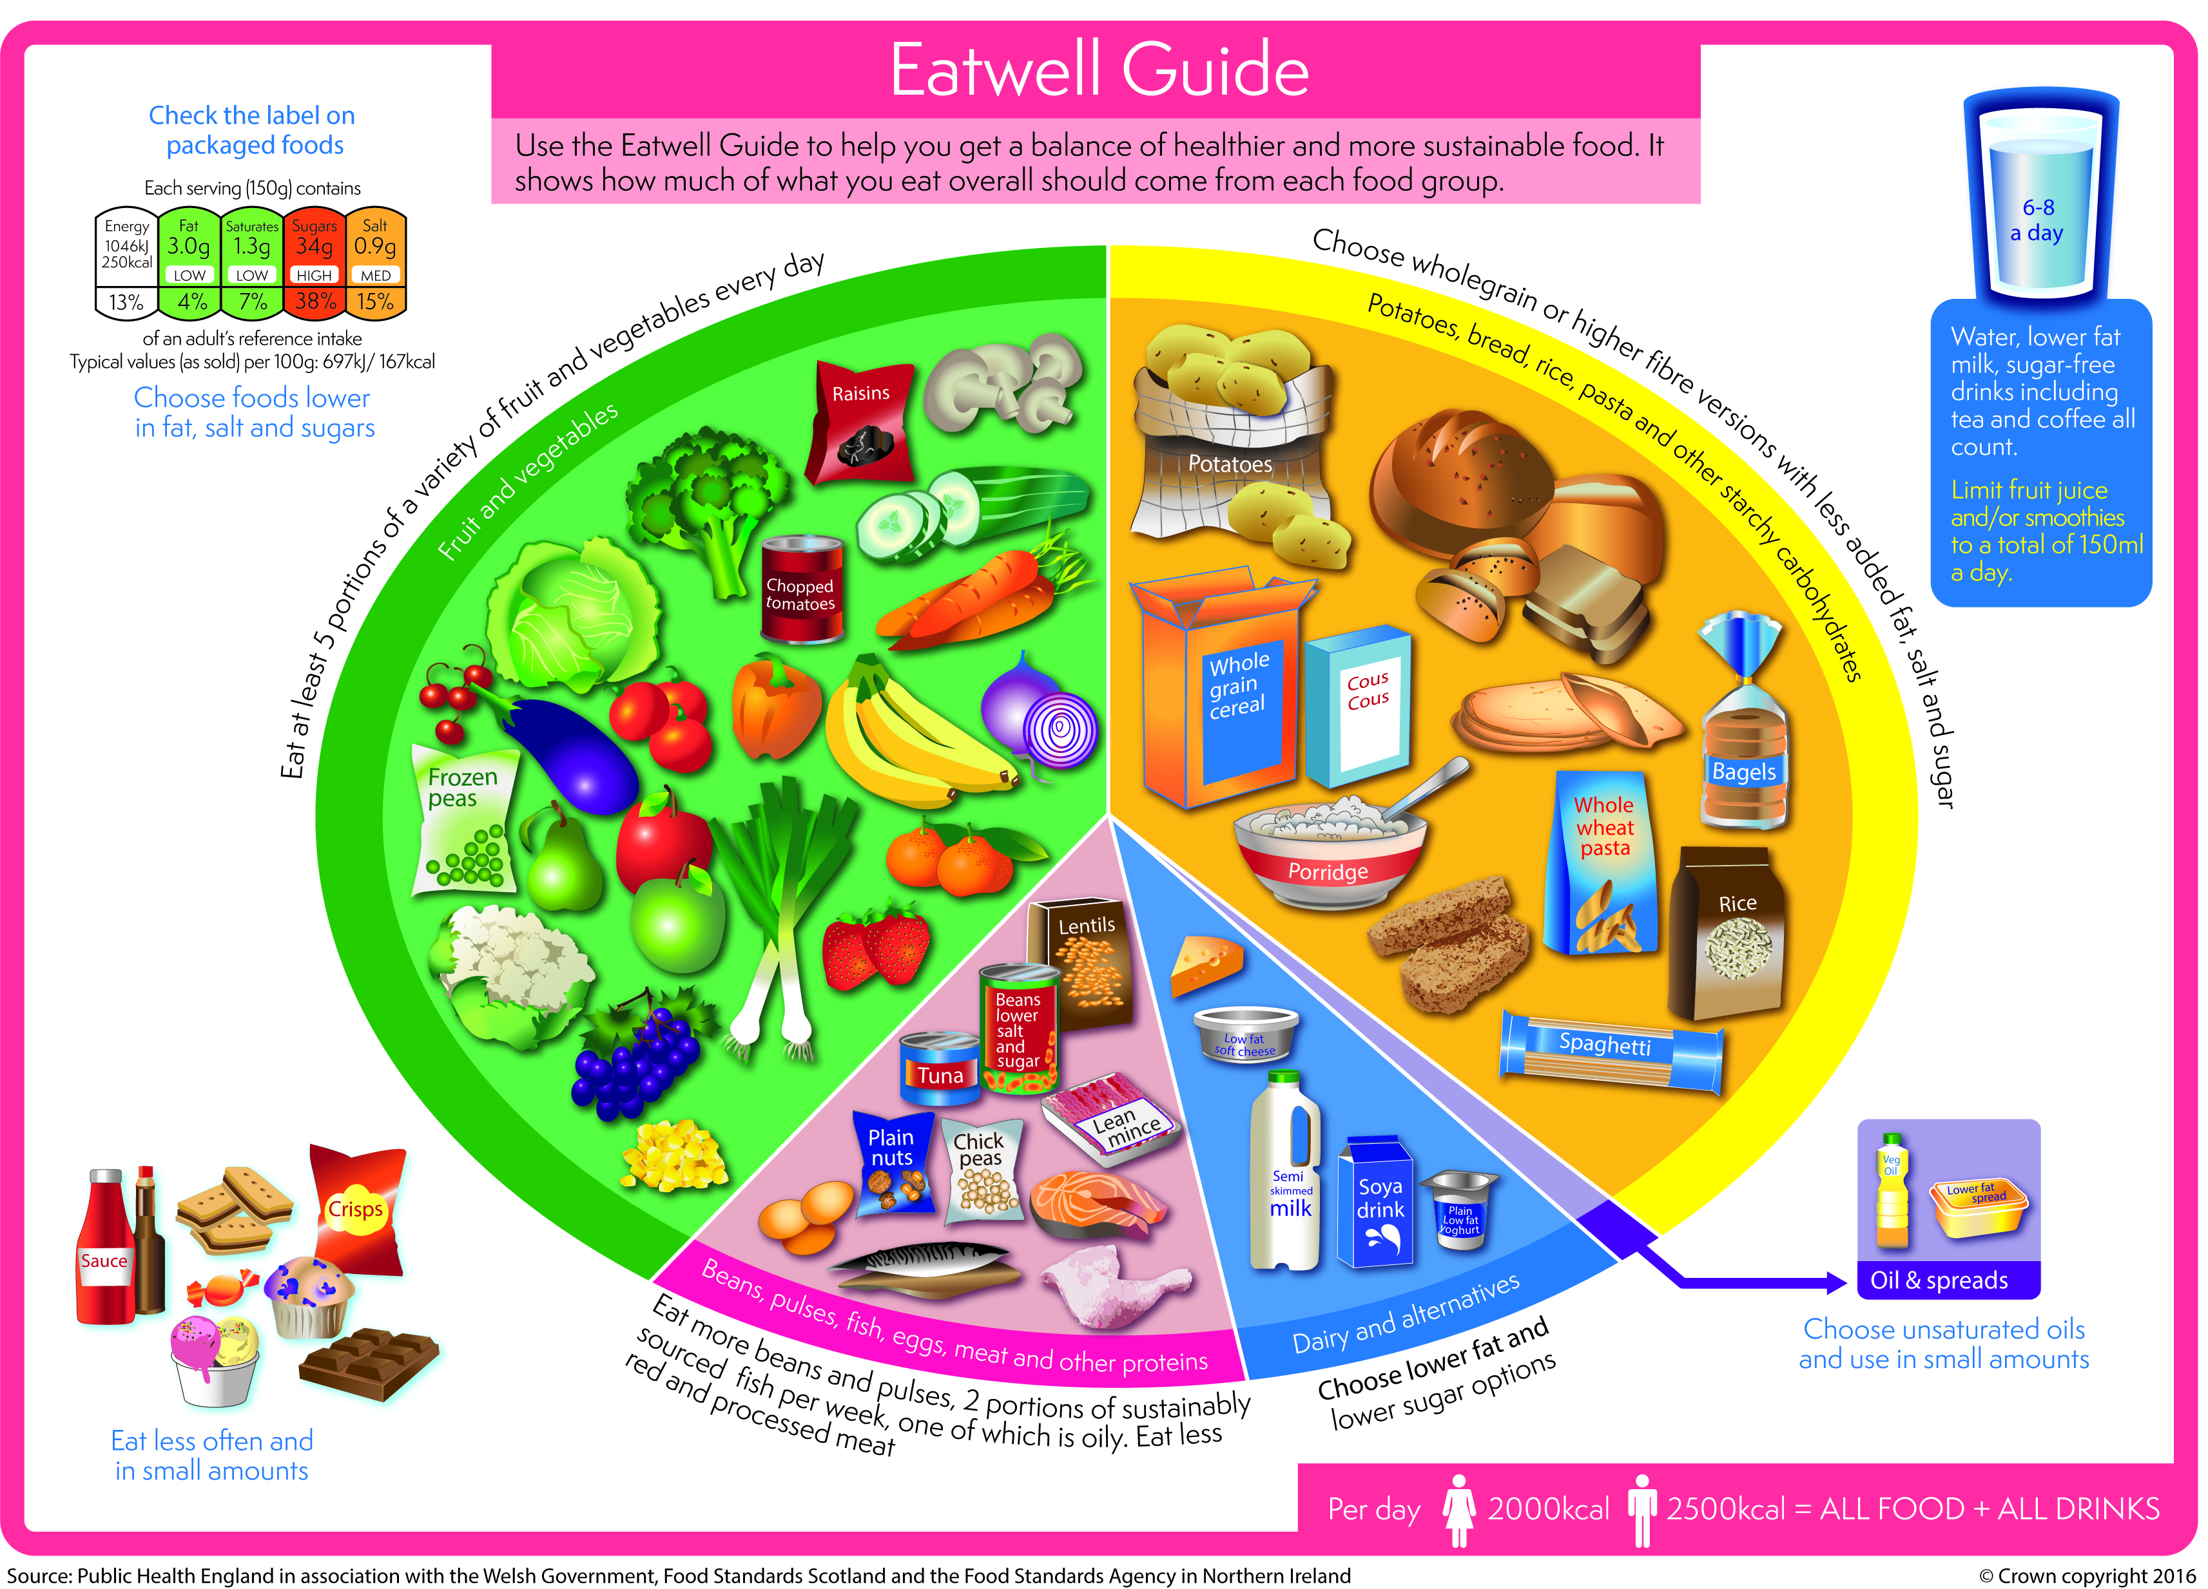

Children under the age of 2
The Eatwell Guide does not apply to children under the age of 2 because they have different nutritional needs.
Between the ages of 2 and 5, children should gradually move to eating the same foods as the rest of the family in the proportions shown in the Eatwell Guide.

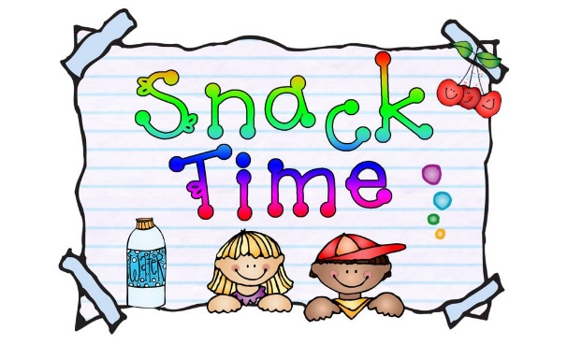
Snack Time Information

At Tots and Bright Beginnings we encourage and support our families to give children a healthy and nutritious diet.
As part of a healthy meal routine, children should be offered 2 healthy snacks across the day. One mid-morning (between breakfast and lunch) and one mid- afternoon (between lunch and tea). This helps children to maintain their energy levels and provides them with important nutrients to support their growth, development, and learning.

The learning developments of snack time
- Develops social skills through interaction and co-operation with others.
- Develops language skills as adults and children talk together about what they are eating.
- Children are more easily encouraged to try new foods by watching what others eat.
- Learning about health and self-care by washing hands before eating.

At Tots and Bright Beginnings we have snack time at 10am and 3pm and all snacks are to be provided by parents, we have listed some examples below-
- Vegetables
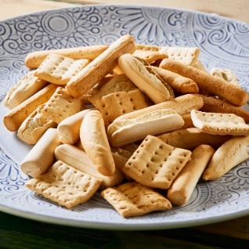
- Fruits
- Dairy foods (And non-dairy alternatives)
- Rice Cakes/crackers
- Bread sticks/pitta bread with hummus
- Plain Brioche or Croissant
- Cereal bar (non-chocolate)

PLEASE ENSURE YOU ONLY BRING 2 ITEMS IN FOR YOUR CHILD FOR EACH SNACK TIME AND ONE OF THESE SHOULD BE A FRUIT OR VEGETABLE OPTION.

WE WILL NOT GIVE THE CHILDREN - CAKES, CHOCOLATES OR SWEETS AT A SNACK TIME.
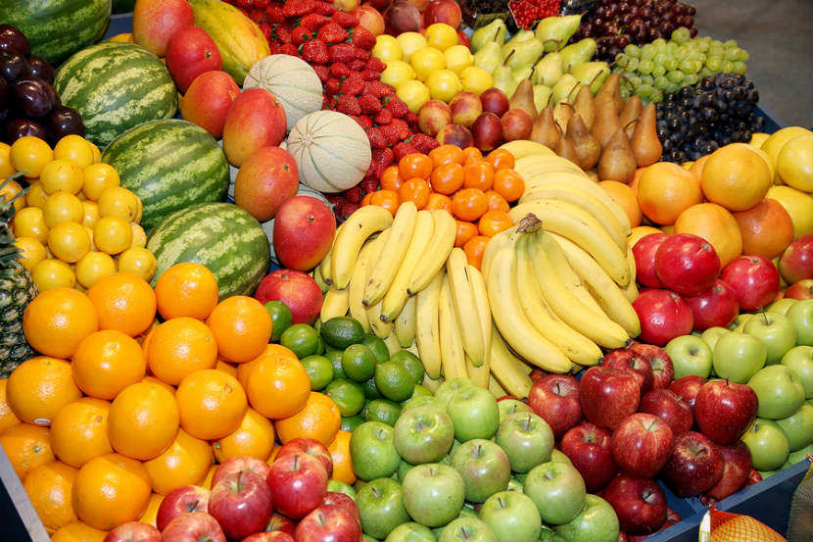
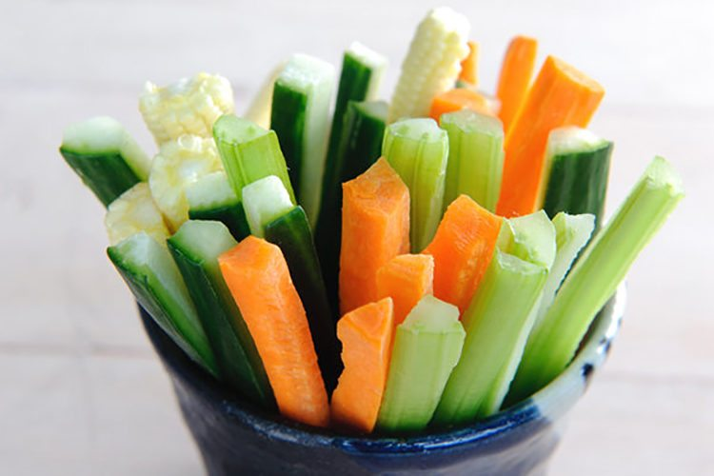

Water
We ask that parents provide their children with a named water bottle daily and we make children aware that water is always available and encourage them to drink regularly throughout the day.



Lunch Time at Tots and Bright Beginnings

The Lunch Box
A small inexpensive plastic box is perfectly acceptable.
Please do not forget to label your child's name on the outside.

Keeping it cool
Although we store the lunch boxes in a cool place out of direct sunlight, a small freezer pack must be inside to keep items cool, in the summer you might want to make this a bigger one or put two in.

The Packed Lunch
Here at Tots and Time Out and Bright Beginnings we are always trying to promote healthy eating during our snack times and lunch times.

We would like parents to work with us in making sure each child has the healthiest lunch they possible can. Below is what we would expect a lunch box to look like.

- 1 Sandwich, Wrap, Roll or Pitta or Rice or Pasta Salad – Remember children up to approx. 3 years only need ½ Sandwich
- 1 Savoury Extra – Oven Baked Crisps, Breadsticks, Small Sausage Roll, Scotch Eggs
- 1 Vegetable Option
- 1 Fruit Option
- 1 Dairy Option – Yoghurt, Cheese
- 1 Small Treat such as small cake, cookie/biscuit, Pretzels, Cereal Bar. We will not give the children sweets or chocolate bars.

The above are just suggestions, there are many more you could add.
Key Points
- Keep it small
- Variety- Try different fruit, Bread and Vegetables
- One small treat only
- Gradual change is best. It can take up to 20 tastes for a child to get used to new food- so keep trying!
- We do not allow children to have chocolate spread at Nursery.

What is a portion ?
A good guide is “what will fit into a cupped hand”. This will increase as your child gets older.

Some lunch box Ideas

Lunch box 1 “Quick and easy”
- Small Pitta filled with Chicken and Cucumber
- Portion of Breadsticks and Hummus
- Cereal bar
- Apple or Satsuma
- Small Yoghurt drink

Lunch box 2 “No food in the house- rush to the shops”
- 1 small Ham roll
- Oven Baked Crisps
- 1 Babybel Cheese
- Banana or Raisins
- 1 small packet of Pretzels

Lunch box 3 “Lets make something together”
- Cheese and Cucumber Sandwiches (use biscuit cutters to make fun shapes)
- Scotch Egg
- Cucumber and Tzatiki
- Strawberries
- Small Fairy Cake

ALLERGY ALLERTS – PLEASE REMEMBER WE ARE A NUT FREE NURSERY

Choking Hazards and Banned Foods
Please be aware the following items are not allowed in snack boxes due to them being HIGH risk choking hazards UNLESS THEY ARE CUT INTO QUARTERS. If they are not cut correctly they will not be given to your child to eat.

- Cherry Tomatoes
- Cocktail Sausages
- Grapes
- Olives

Popcorn is banned from Tots and Bright Beginnings due to being a very high risked choking food.

If you want your child to have fruit which has a stone in e.g Plum, Nectarine, Peach it MUST be destoned and cut for Nursery.

Physical Development

Being physically active every day is important for the healthy growth and development of babies, toddlers and pre schoolers.
For this age group, activity of any intensity should be encouraged, including light activity and more energetic physical activity.

Babies (under 1 year)
Babies should be encouraged to be active throughout the day, every day in a variety of ways, including crawling.
If they're not yet crawling, encourage them to be physically active by reaching and grasping, pulling and pushing, moving their head, body and limbs during daily routines, and during supervised floor play.
Try to include at least 30 minutes of tummy time spread throughout the day when they're awake.
Once babies can move around, encourage them to be as active as possible in a safe and supervised play environment.

Toddlers (aged 1 to 2)
Toddlers should be physically active every day for at least 180 minutes (3 hours). The more the better. This should be spread throughout the day, including playing outdoors.
The 180 minutes can include light activity such as standing up, moving around, rolling and playing, as well as more energetic activity like skipping, hopping, running and jumping.
Active play, such as using a climbing frame, riding a bike, playing in water, chasing games and ball games, is the best way for this age group to get moving.

Pre-schoolers (aged 3 to 4)
Pre-schoolers should spend at least 180 minutes (3 hours) a day doing a variety of physical activities spread throughout the day, including active and outdoor play. The more the better.
The 180 minutes should include at least 60 minutes of moderate-to-vigorous intensity physical activity.
Children under 5 should not be inactive for long periods, except when they're asleep. Watching TV, travelling by car, bus or train, or being strapped into a buggy for long periods are not good for a child's health and development.
All children under 5 who are overweight can improve their health by meeting the activity guidelines, even if their weight does not change. To achieve and maintain a healthy weight, they may need to do additional activity and make dietary changes.

Physical activity ideas for children under 5
All movement counts. The more the better.
- tummy time
- playing with blocks and other objects
- messy play
- jumping
- walking
- dancing
- swimming
- playground activities
- climbing
- active play, like hide and seek
- throwing and catching
- scooting
- riding a bike
- outdoor activities
- skipping

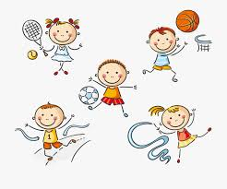

Dental Care
You can start brushing your baby's teeth as soon as they start to come through. Use a baby toothbrush with a tiny smear of fluoride toothpaste.
Don't worry if you don't manage to brush much at first. The important thing is to get your baby used to brushing their teeth as part of their daily routine. You can help by setting a good example and letting them see you brushing your own teeth.

Tooth brushing tips for babies
- Use a tiny smear of toothpaste for babies and toddlers up to 3 years old, and a pea-sized amount for children aged 3 to 6 years.
- Gradually start brushing your child's teeth more thoroughly, covering all the surfaces of the teeth. Do it at least twice a day: just before bed and at another time that fits in with your routine.
- Not all children like having their teeth brushed, so you may have to keep trying. Make it into a game or brush your own teeth at the same time and then help your child finish their own.
- The easiest way to brush a baby's teeth is to sit them on your knee, with their head resting against your chest. With an older child, stand behind them and tilt their head backwards.
- Brush the teeth in small circles, covering all the surfaces, and encourage your child to spit the toothpaste out afterwards. There's no need to rinse with water, as this will wash away the fluoride.
- Supervise brushing to make sure your child gets the right amount of toothpaste and they're not eating or licking toothpaste from the tube.
- Carry on helping your child brush their teeth until you're sure they can do it well enough themselves. This will normally be until they're at least 7.

Taking your baby to the dentist
NHS dental treatment for children is free. Take your child with you when you go for your own dental appointment so they get used to the idea.
To find a dentist, you can use our services search, ask at your local clinic, or contact NHS England on 0300 311 22 3 or email england.contactus@nhs.net.

Sugar and tooth decay
Sugar causes tooth decay. It's not just about the amount of sugar in sweet food and drinks, but how long and how often the teeth are in contact with sugar.
Lollipops and sweet drinks in a formula bottle are particularly damaging, because they bathe the teeth in sugar for long periods of time. The acid in drinks like fruit juice and squash can harm teeth as well.
The sugars found naturally in whole fruit and milk are less likely to cause tooth decay, so you don't need to cut down on these types of sugars.

How to cut down sugar in your child's diet
These tips will help you reduce the amount of sugar in your child's diet and prevent tooth decay:
- Avoid sugar-sweetened drinks – the best drinks for young children are their usual milk and water.
- It's OK to use bottles for expressed breast milk, formula milk, or cooled boiled water. But using them for juices or sugary drinks can increase tooth decay.
- From 6 months old, you can offer babies drinks in a non-valved free-flowing cup.
- When your baby starts eating solid foods, encourage them to eat savoury food and drinks with no sugar. Check if there's sugar in pre-prepared baby foods (including the savoury ones), rusks and baby drinks.
- If you choose to give your child sweet foods or fruit juice, only give them at mealtimes. Remember to dilute 1 part juice to 10 parts water. Your child should have no more than 1 drink of fruit juice (150ml) in any 1 day as part of their 5 A Day.
- Don't give your child biscuits or sweets – ask family and friends to do the same. Offer things like stickers, hair slides, crayons, colouring books and bubbles instead. They may be more expensive than sweets, but they last longer.
- At bedtime or during the night, only give your child breast milk, formula or cooled boiled water.
- If your child needs medicine, ask your pharmacist or GP if there's a sugar-free option.
- Check your whole family's sugar intake
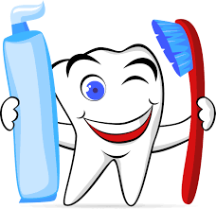

Our Community

Below is a list of some local Dentists and Doctors for you to contact if you have any concerns regarding your child’s Physical development.
It is very important to always make sure your child is registered with a Doctor and Dentist at all times.

Local Dentistry Practises

Seaside Dental Practise – 01323 408999
White House Dental practise – 01323 725224
Lushington Road Dental Practise – 01323 720094
Trinity Dental Practise – 01323 727550
My Dentist – 01323 725081
Dentistry for you – 01323 735005
Southcliffe Dental Practise – 01323 647061

Local Doctor Surgeries

Harbour Medical Practise – 01323 470370
Grove Road Surgery – 01323 720606
Seaside Medical Practise – 01323 725667
Princess park Health Centre – 01323 744644
Park Practise – 01323 502200
Enys Road Surgery – 01323 410088
Lighthouse Medical Practise – 01323 735044
Arligton Road Surgery – 01323 727531
Bolton House Surgery – 01323 730537
Green Street Clinic – 01323 736664

