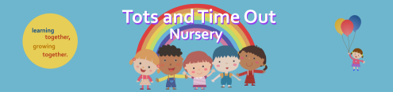
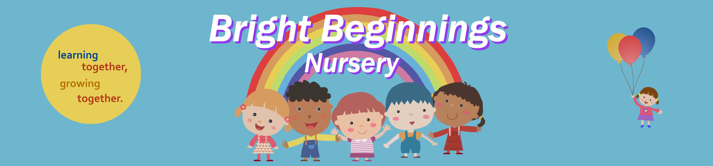
34 Eshton Road, Eastbourne BN22 7ES 93 Enys Road, Eastbourne BN21 2DX
01323 726132 01323 648484

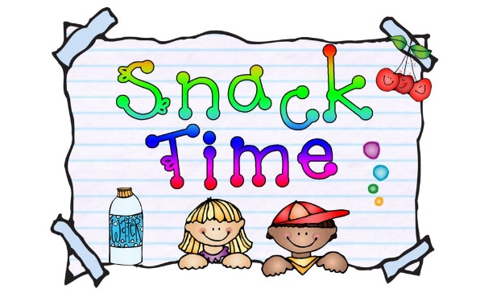
Snack Time Information

At Tots and Bright Beginnings we encourage and support our families to give children a healthy and nutritious diet.
As part of a healthy meal routine, children should be offered 2 healthy snacks across the day. One mid-morning (between breakfast and lunch) and one mid- afternoon (between lunch and tea). This helps children to maintain their energy levels and provides them with important nutrients to support their growth, development, and learning.

The learning developments of snack time
- Develops social skills through interaction and co-operation with others.
- Develops language skills as adults and children talk together about what they are eating.
- Children are more easily encouraged to try new foods by watching what others eat.
- Learning about health and self-care by washing hands before eating.

At Tots and Bright Beginnings we have snack time at 10am and 3pm and all snacks are to be provided by parents, we have listed some examples below-
- Vegetables
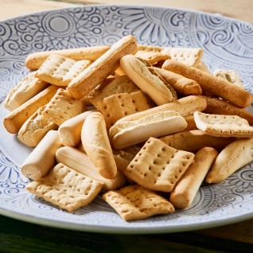
- Fruits
- Dairy foods (And non-dairy alternatives)
- Rice Cakes/crackers
- Bread sticks/pitta bread with hummus
- Plain Brioche or Croissant
- Cereal bar (non-chocolate)

PLEASE ENSURE YOU ONLY BRING 2 ITEMS IN FOR YOUR CHILD FOR EACH SNACK TIME AND ONE OF THESE SHOULD BE A FRUIT OR VEGETABLE OPTION.

WE WILL NOT GIVE THE CHILDREN - CAKES, CHOCOLATES OR SWEETS AT A SNACK TIME.

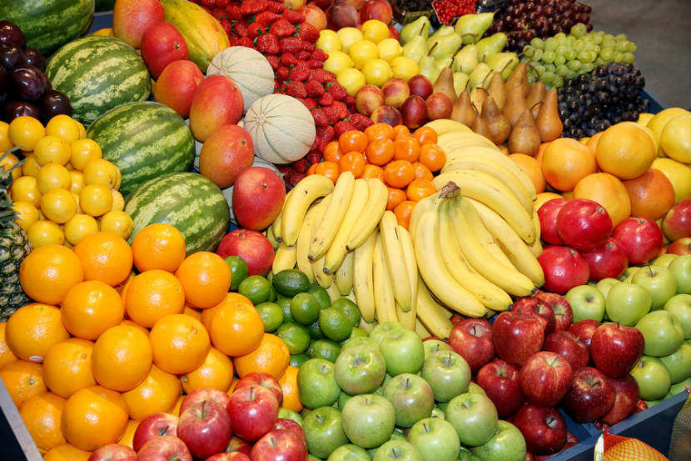
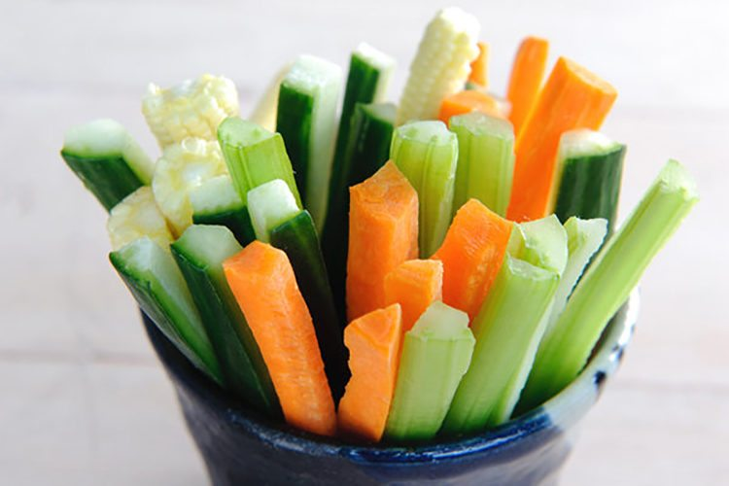

Water
We ask that parents provide their children with a named water bottle daily and we make children aware that water is always available and encourage them to drink regularly throughout the day.

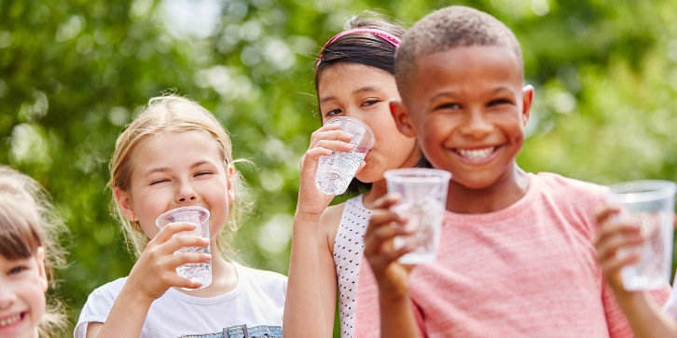

Choking Hazards and Banned Foods
Please be aware the following items are not allowed in snack boxes due to them being HIGH risk choking hazards UNLESS THEY ARE CUT INTO QUARTERS. If they are not cut correctly they will not be given to your child to eat.

- Cherry Tomatoes
- Cocktail Sausages
- Grapes
- Olives

Popcorn is banned from Tots and Bright Beginnings due to being a very high risked choking food.

If you want your child to have fruit which has a stone in e.g Plum, Nectarine, Peach it MUST be destoned and cut for Nursery.

Please note we are a NO NUT NURSERY!

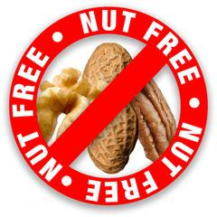

If you have any questions please speak to the Management Team.

